**Phase 2 - Group 23 (CSCI-320-03/04)**

Normalization Analysis

As of this submission, our database is in third normal form. First Normal Form is satisfied by the fact that all data has been properly divided into database tables, and that these tables contain only atomic, non-repeating values. Second Normal Form is satisfied by the fact that all attributes in the current table-set serve to describe the object defined by the table’s primary key, and that there are no non-key columns present that do not pertain to the primary key. We meet the requirements of Third Normal Form because with the inclusion of the foreign key dependency chain of Label -> Artist -> Album -> Song and the individual, secondary references included by table (Edition for album, for example), all transitive dependencies have been eliminated. Thus, the first three normal forms are satisfied, and the database is in Third Normal Form.

Current ER Diagram

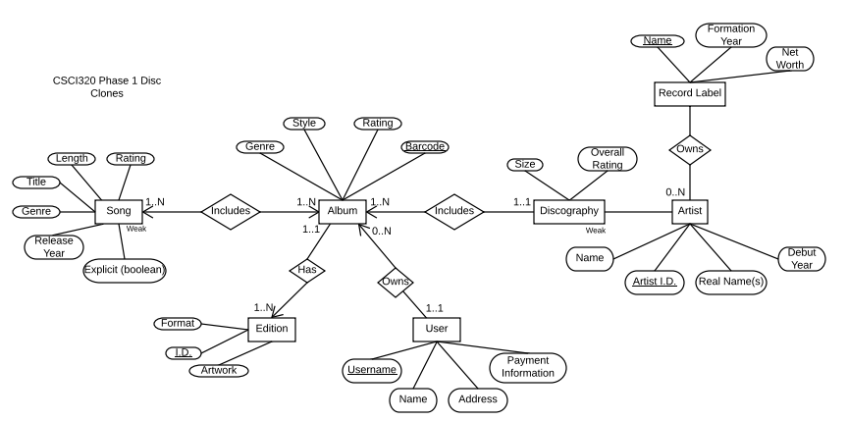

Run Application

* Application runs with Maven and Spark as dependencies
* Application also uses the postgreSQL driver to connect to the database
  + To install postgreSQL driver

1. Open project in IntelliJ
2. File > Project Structure
3. Modules > Dependencies
4. Click the “+” under the list of dependencies
5. JARs or Directories…
6. Choose *postgresql-42.1.4.jar* which is located in the *src* folder

* Run *mvn compile exec:java* in the folder’s root (where pom.xml is)
* Access application at localhost:4567 (Signing up, signing in and search all work)

Please note that, if you are only going to analyze the code written for SQL statements and not the entire application, all the SQL queries written up until this point can be found in the SQLManager.java file in the directory src -> main -> java -> com -> DiscogsApp -> appl -> SQLManager.java. Also, please do not try and use any of the admin tools in their current state, as they are mostly stubbed and will at best not work and at worst crash the entire program.